Assignment No.6

1. Declare a single-dimensional array of 5 integers inside the main method. Traverse the array to print the default values. Then accept records from the user and print the updated values of the array.

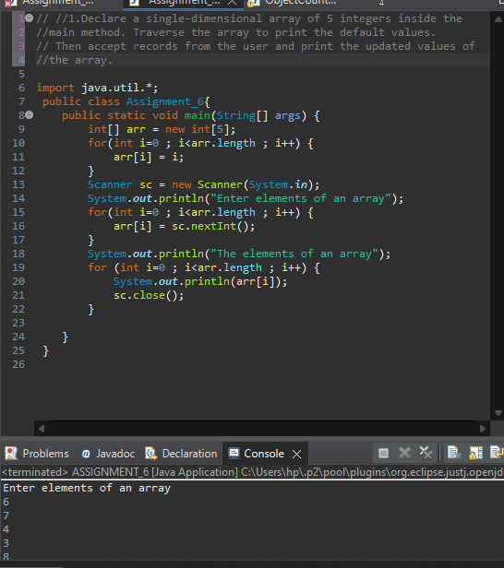

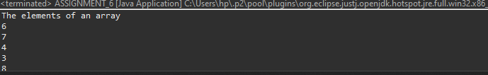

1. Declare a single-dimensional array of 5 integers inside the main method. Define a method named acceptRecord to get input from the terminal into the array and another method named printRecord to print the state of the array to the terminal.

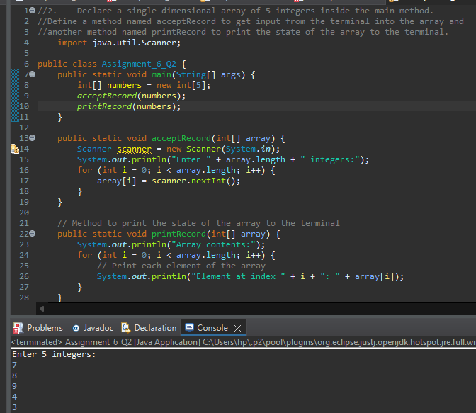

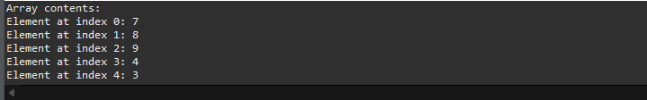

1. Write a program to find the maximum and minimum values in a single-dimensional array of integers.

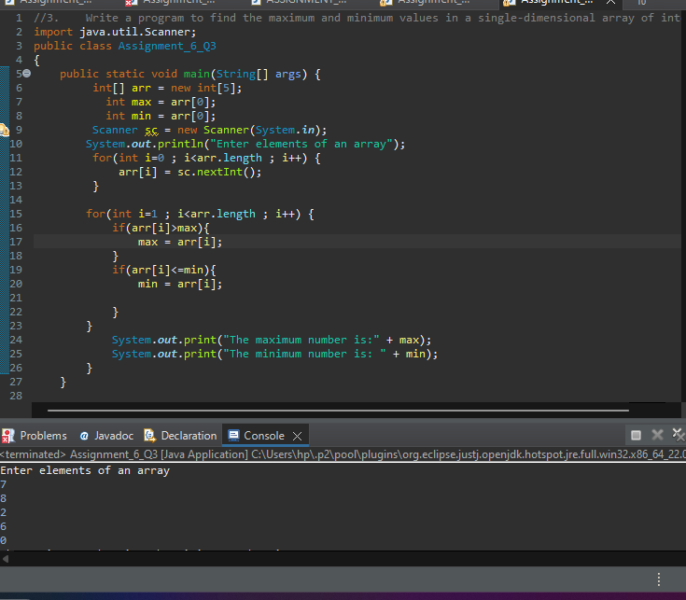

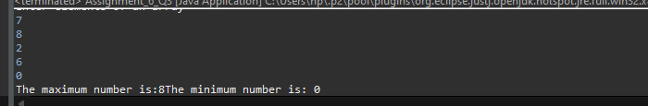

1. Write a program to remove duplicate elements from a single-dimensional array of integers.

